Web Technology
Galway Hotel
Report
RADKA KOTULAKOVA – STUDENT REBEKA KOTULAKOVA - STUDENT
17.11.2024

Contents
1. Introduction 3
Purpose of the Report 3
2. Planning Phase 3
2.1 Purpose of the Website 3
2.2 Target Audience 3
2.3 Competitor Analysis 3
Competitors: 3
2.4 Personas 5
Andrew Johnson 5
Summer Wren 7
2.5 Attracting Visitors 9
3. Design Elements 9
3.1 Colour Scheme 9
3.2 Layout and Navigation 9
4. Wireframes 10
Homepage 10
Rooms Page: 11
Services Page: 12
Students Page 13
Contact Us Page 14
5. Implementation 15
5.1 Website Development 15
5.2 Challenges and Solutions 15
6. Time Management 15
Team Roles: 15
Total Time Spent: 15
7. Weekly Updates 15
Week-by-Week Progress: 15
8. Conclusion 16

Figure 1 - Andrew Johnson (photo) 4
Figure 2 - Summer Wren (Photo) 6
Figure 3 - Homepage (Wireframe) 9
Figure 4 - Rooms page (Wireframe) 10
Figure 5 - Services page (Wireframe) 11
Figure 6 - Students page (Wireframe) 12
Figure 7 - Contact Us page (Wireframe) 13

1. Introduction

1.1 Purpose of the Report
This report describes completing the website for Galway Hotel. It describes the planning stage to final outcome. This report provides a detailed explanation of the design, layout, and color decisions with some CSS code explanation too. Wireframes are included in this report so as our customer´s perosonas.

2. Planning Phase

2.1 Purpose of the Website
- Primary Purpose: The main purpose of the Galway Hotel website is to attract students to find affordable, convenient, and well-facilitated accommodations and international people who would like to stay in Galway for a few nights and have a low budget. To make finding accommodation in Galway less frustrating for young people who don´t like to spend all their savings and also to enable students and young people to book a room online easily so it saves the time that they would spend searching for rooms.
- Secondary Purpose: Promote affordable accommodation with all the necessary amenities for young adults and students to live. Support the independence of students living on their own in private rooms for more comfort and privacy. The purpose of the website is to make people struggle less with securing a place to stay.

2.2 Target Audience
- Primary: University Students who need long-term accommodation.
- Secondary: Short-term solo travellers who want to travel low-cost.
- General: Young people (age 18-30) who can´t afford expensive hotels or struggle to find a place to stay, short-term or long-term.

2.3 Competitor Analysis

Competitors:
The main competitors for Galway Hotel Website are websites that offer the same service such as housing providers in Galway or Ireland. Those websites are Daft.ie or Housingpower.ie which offer students accommodation. Also, websites like Booking.com where people can find rooms in their budget.
These websites have familiar interfaces and positive reviews. You can also filter your options by adding your budget or your preferences. All these websites are well-known among young people and students and people are scared to get scammed by a new websites with affordable prices for rooms. Our website should try to get as many positive reviews and get students to talk about it.
The idea of offering affordable accommodation to young people who like to travel and students who are desperately looking for a place to live while studying is the biggest advantage we have compared to our competitors.

Snoozles Hostel Galway
Strengths: City Centre Location, Offers Students Accommodation, Bus Connection
Weaknesses: High Price, Hostel Bunk Beds Rooms, Unclear Layout of Website

Kinlay Hostel Galway
Strengths: Positive Reviews, City Centre Location, Appealing Website,
Weaknesses: Minimal Focus On Privacy, No Offers for Students, Shared Bunk Beds

Takeaways:
Comparing the competitors we have decided to put more effort into building an easy-to-navigate website with a simple layout. We want to make it mobile-friendly for all the user to be able to book from their phones. We want to focus on the privacy and comfort of short-term and long-term guests. We provide necessary amenities for people to have everything under one roof.

2.4 Personas

Andrew Johnson


Demographics
Figure 1 - Andrew Johnson (photo)
- Age: 21 years
- Gender: Male
- Occupation: Shop Assistant in Dunnes Stores
- Education: University of Galway
3rd Year, studying Agricultural Science
- Location: Claremorris, Ireland
- Nationality: Irish
- Income Level: Limited income (reliant on part-time work, and family support, SUSI grant)

Biography
Andrew is a 21-year-old student living in Galway. He grew up in a big 6-member family. He has two younger sisters and one older brother. He lives in a small cozy house in Claremorris where he shares a room with his brother who is also a student. Andrew grew up on the farm, so farming was always his passion. He spent countless hours tending to animals, helping with harvests, and learning how to manage a farm. Andrew decided to channel his interests into academics, and he is currently studying Agricultural Science at the University of Galway. He wants to become a Farm Advisor, helping farmers modernize their operations and maximize their productivity.
Andrew decided to stay long-term in the Galway Hotel. Rent was affordable for him, and he doesn’t like sharing rooms with others, so he appreciates having the en-suite room all for himself
Andrew works part-time at the Dunnes stores as a shop assistant to earn some money for his rent and manage his car expenses.
Andrew enjoys staying active, so he spends his free time in the gym. He tries to go at least 3 times a week. Having a gym on the ground floor for free was also a reason why Andrew decided to choose the Galway Hotel for his accommodation. He also likes to go to pubs in the evening and spend some time with his friends watching a match.

Goals and Aspirations
- Affordable and comfortable accommodation close to the university
- No-sharing en-suite room
- Opportunities to socialize with peers or other students
- Have freedom timewise and moneywise

Challenges and Pain Points
- Budget Limit: Finding accommodation an affordable price
- Sharing: Finding room just for himself
- Quality: Wants gym and good food and clean room
- Socializing: Prefers accommodation with other students or peers

Preferred Platforms and Content Consumption
- Frequently browsed accommodation websites like (e.g., daft.ie, housingpower.ie) and university housing resources.
- Active on social media platforms like Instagram and Snapchat for texting his friends and sending reels. Non-frequently Active on Facebook

Behaviour on Website
- Visits websites using his smartphone or laptop, often while multitasking.
- Compares room photos, pricing, and student-friendly reviews before making decisions.
- Trusting friend recommendations more than website reviews

What He Wants From the Website
- Easy menu system with direct links to rooms and services
- Visible room options and rent information in bullet points like price and term
- Website should be accessible for phones
- Accessible contact details, mainly email addresses, because he hates calling

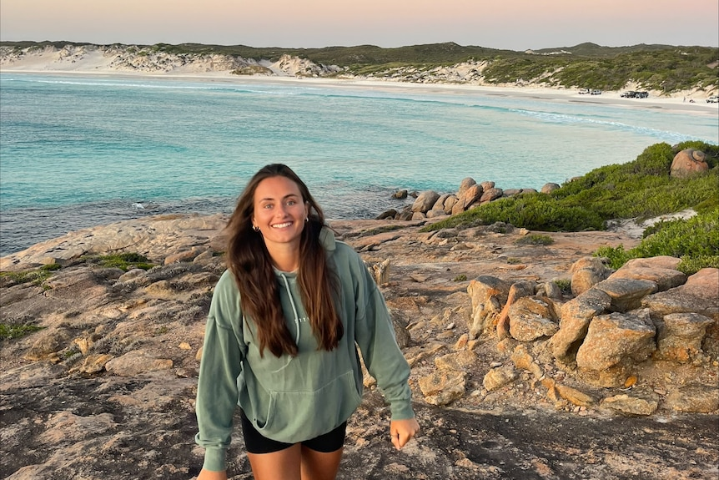
Summer Wren
Figure 2 - Summer Wren (Photo)

Demographics
- Name: Summer Wren
- Age: 27 years
- Occupation: Freelance Graphic Designer
- Location: Melbourne, Australia
- Nationality: Australian
- Income Level: Limited income (seasonal projects, side hustles, and savings)

Biography
Summer is a 27-year-old freelancer working as a graphic designer on a seasonal project. She is from Melbourne (Australia) and has a passion for exploring new cultures and making friends. She is currently single and not looking for a partner. Summer is focusing on living her life to the fullest. Now, she is traveling through Ireland for two weeks. She would like to stay in Galway while traveling the west side of Ireland. This is why she has chosen the Galway Hotel for her stay. The affordable ensuite room has what she is looking for private space with essential amenities like a small kitchen, laundry room, shower, and gym.

Summer is an extroverted girl who loves to socialize with people she meets on her travels. She loves to dance with her peers at local spots. She also cares about her health which is why she goes to the gym regularly. Summer loves to cook her meals to support her healthy lifestyle. She loves to post pictures on Instagram from her travels and keep her friends and family updated on what is she up to.

Goals and Aspirations
- Comfort and Independence – Summer prefers accommodation with her own privacy and freedom to cook meals, clean, do her laundry, and feel at home.
- Health and Fitness – Summer loves to workout on her journeys so the gym facility in the hotel is something she values a lot.
- Socializing – She loves meeting new people and connecting with like-minded individuals. The hotel provides a shared co-working area for socializing.
- Simplicity – Summer often makes plans on the go on her phone. She needs a mobile-friendly website with quick necessary information and a simple booking system.

Challenges and Pain Points
- Heavy website: The website is cluttered with unnecessary information, making it hard to find key details about pricing or availability.
- Overcrowded: Noisy spaces with too many people that compromise her need for personal space
- Lack of transparency: Misleading information about safety measures or cleanliness standards.

Preferred Platforms and Content Consumption
- Frequently browses websites like booking platforms (e.g., Airbnb, Booking.com) or Facebook groups about accommodation.
- Active on social media platforms like Instagram and Facebook, watching short videos on her phone known as reels. She often posts her content from traveling on Instagram.
- She uses Gmail and WhatsApp for more formal communication or reservations of rooms and tickets.

Behaviour
- Visits websites using her smartphone or laptop, often while multitasking.
- Doesn´t compare more than 2 websites if they are in her budget and look good.
- Engages with blogs or forums for advice on accommodation and living tips.

What She Wants From Your Website
- Aesthetic Modern Appeal:
The yellow and black theme resonates with Summer’s upbeat and vibrant personality. She finds the design inviting and cheerful.
- Quick Navigation:
  - Quick Access to room and pricing options with all necessary information is crucial. A simple booking makes it less stressful for Summer.
- Responsive Design:
  - Website should be mobile-friendly and load quickly.
- Clear Highlight of Amenities:
  - She wants to know what she can expect when arriving in a new place. If she knows there is a laundry and gym in a building she can spend more time traveling than worrying about where to wash her clothes or where is the nearest gym.

2.5 Attracting Visitors
- Strategy: Using keywords for searching like "Galway hotel," "affordable student housing in Galway," and "low-cost accommodations in Galway."
- Collaborations: Contacting universities and let them know about our service. Creating posters and putting them up on university boards. Doing a giveaway with our branded things at the universities. Also, collaborating with local tourism boards and also contacting travel agencies.
Promotion: Launching the website on social media like Instagram and Facebook and paying for ads targeting students or young people the 18-30 age with catchy phrase like “Finding accommodation in Galway doesn’t always have to be a nightmare.”

3. Design Elements

3.1 Colour Scheme
We decided to use a yellow and black colour palette. Yellow symbolizes energy, happiness, and joyfulness. So overall it creates a welcoming and friendly design. Black colour ensures simplicity and visibility to all the text. Both colours create a modern, youthful, and clean design that will catch the customer’s eye from the beginning.

3.2 Layout and Navigation

Homepage:
  - Banner image with a logo
  - Quick links to "Book Now,"

Navigation Menu:
  - Sticky header with links to:
    - Home
    - Rooms
    - Services
    - Students
    - Contact us

4. Wireframes
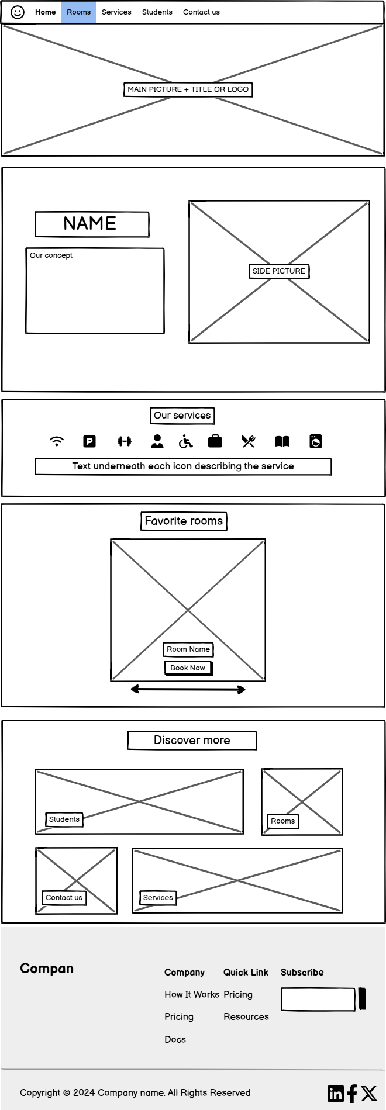
Homepage: Includes main intro picture with brief explanation of our concept of housing

Figure 3 - Homepage (Wireframe)
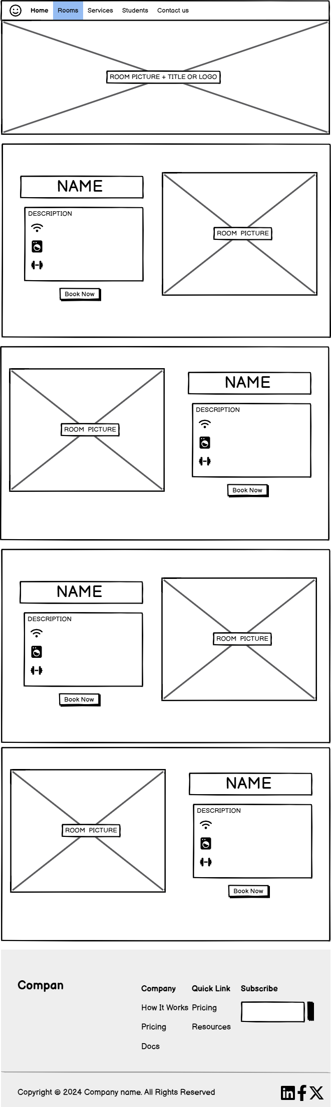
Rooms Page: Grid layout with room images, descriptions, and pricing.

Figure 4 - Rooms page (Wireframe)
Services Page: Icons and brief descriptions for amenities (kitchen, laundry, Wi-Fi).
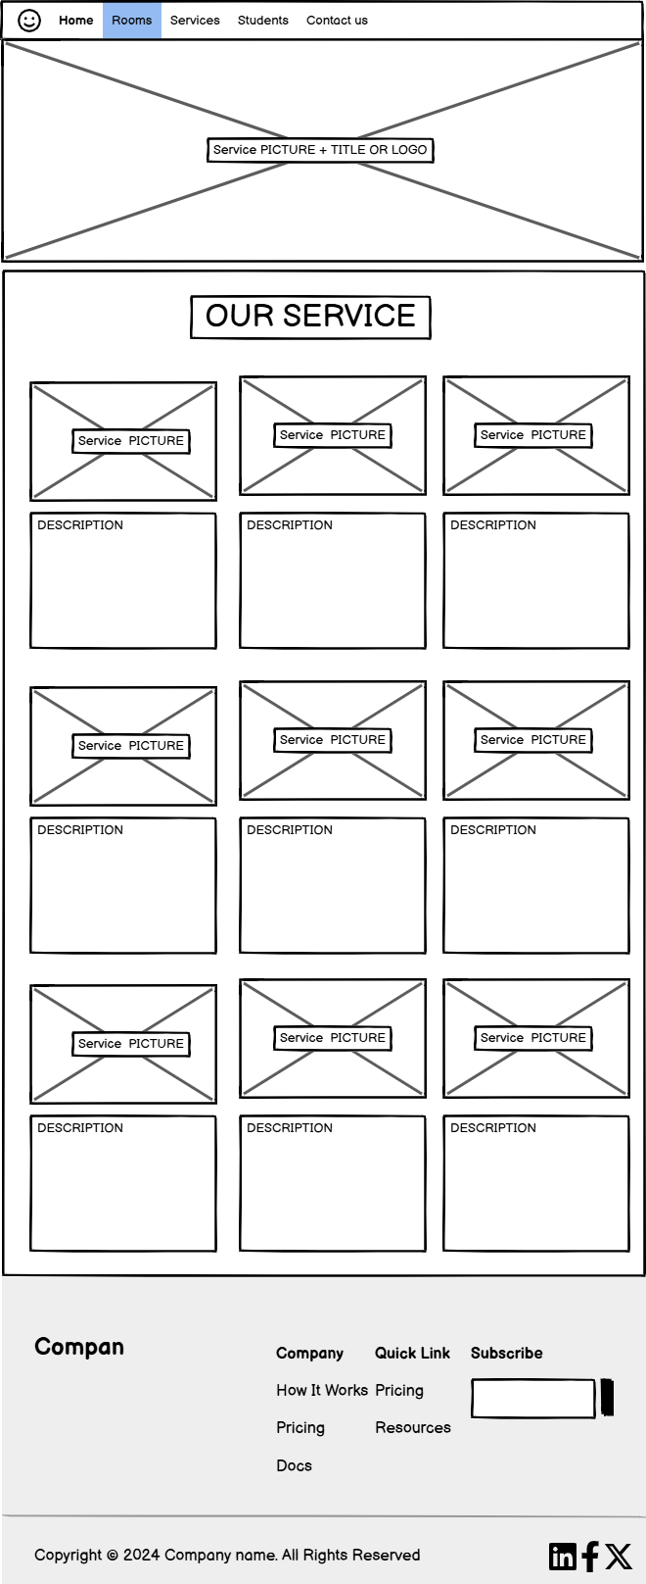
Figure 5 - Services page (Wireframe)
Students Page: Simple form with fields for name, email, and message.
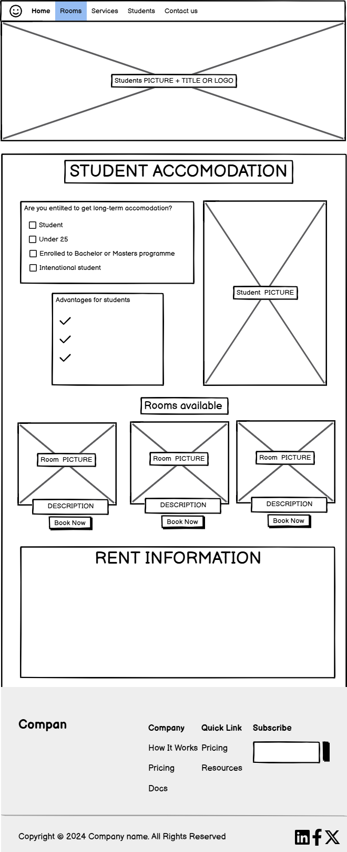
Figure 6 - Students page (Wireframe)
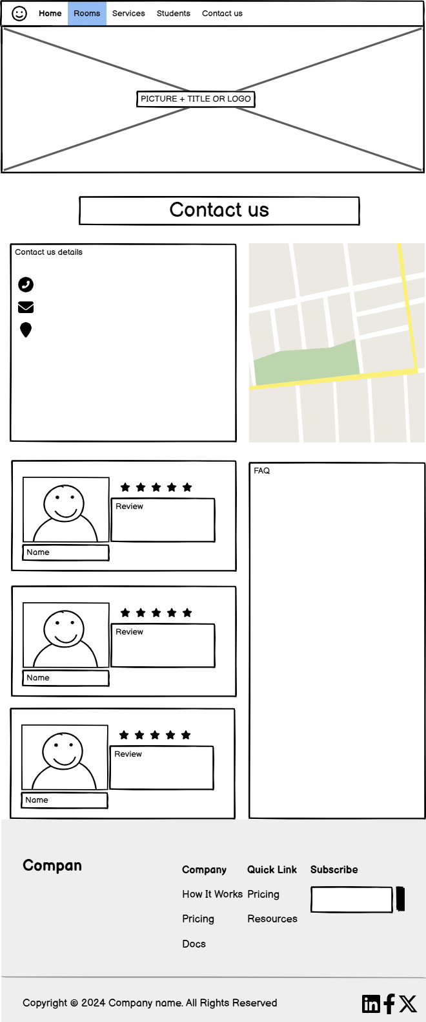
Contact Us Page: Simple form with fields for name, email, and message.
Figure 7 - Contact Us page (Wireframe)

5. Implementation

5.1 Website Development
- Tools Used: HTML, Bootstrap and CSS.

CSS Effects:
  - Buttons: Bright yellow hover effect for emphasis.
  - Typography: font-family: 'Arial', sans-serif;
  - Layout: Grid bootstrap system to ensure responsive design.

CSS codes used:
z-index: 1; = Ensuring text will stay in front of the picture.
padding: 5px 10px; = to make the box bigger and add some space, (top, bottom/left, right).
align-content: center; = To make all rows centered.
top: 280px; = Positioning from the top.
margin-left: auto; & margin-right: auto; = centering in the middle

5.2 Challenges and Solutions
- Challenge: Designing a logo design straight onto picture in CSS.
  - Solution: Using style="display: inline-block;transform:rotate(270deg);" code in HTML to rotate our text and also using <span> to add more styles in CSS.
- Challenge: Adding link to the map with pointing location.
  - Solution: Used Google maps to get location code from share option and then added it to our HTML site.
<iframe src="https://www.google.com/maps/embed?pb=!1m14!1m8!1m3!1d3584.517881406956!2d-9.0564883!3d53.275924!3m2!1i1024!2i768!4f13.1!3m3!1m2!1s0x485b96efc7b75637%3A0xb159008072290002!2sWoodquay%20Hostel!5e1!3m2!1ssk!2sie!4v1732564004965!5m2!1ssk!2sie" width="500" height="450" style="border:0;" allowfullscreen="" loading="lazy" referrerpolicy="no-referrer-when-downgrade"></iframe>

6. Time Management

Team Roles:

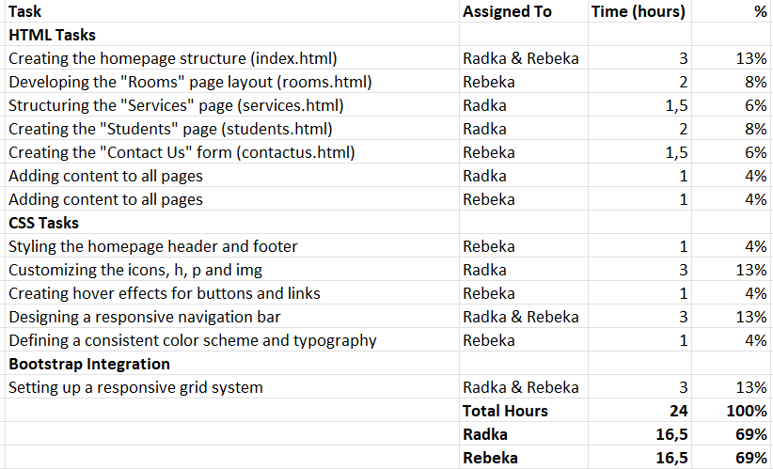Total Time Spent:
- Estimated: 48 hours
- Actual: 24 hours

7. Weekly Updates

Week-by-Week Progress:
- Week 1: Planning and research, including competitor analysis and personas.
- Week 2: Initial wireframes and feedback.
- Week 3: Website prototype with sample pictures and text.
- Week 4: Content adding to all 5 sites.
- Week 5: Website finalization and writing a report.

8. Conclusion
We created a functional good-looking website that has a nice and friendly design. The website has all the important information about accommodation and rooms for students. It is very easy to navigate and get all the information you need. It will make booking a room in Galway easier and cheaper. Our next step would be to advertise our website at colleges or through travel agencies.

